# RPNow – Remote Proctor

Some exams in courses will utilize Remote Proctor Now (RPNow), a remote proctoring system. This system allows you to take your exams at a convenient time as allowed by your faculty. The proctoring of your exam involves recording the visual, audio, and desktop aspects of your exam and exam environment, just as if you were proctored in a classroom setting.

Why are we using RPNow? The integrity of online courses is a growing concern in higher education. Verification of one’s identity in an online course is quickly becoming a mandate for the accreditation of on many programs. In addition, the ease and low cost of hiring someone to take an online course for you and/or an exam is raising additional concerns. Putting safeguards in place, such as RPNow, will ensure the validity of online courses and programs. Students participate in online programs/courses for many reasons including flexibility to hold a job, family demands, etc. – it is important that these online learning opportunities continue to be seen as equal as their face-to-face counterparts.  
  
RPNow is safe for download and has been approved for use by Seton Hall University. [RPNow Privacy Statement](http://www.softwaresecure.com/privacy-statement/)

For verification, you must provide your ID.

You will need a camera, microphone, and a sufficient Internet Connection.

Review the [RPNow system requirements](http://clientportal.softwaresecure.com/support/index.php?/Knowledgebase/Article/View/252/0/system-requirements-remote-proctor-now).

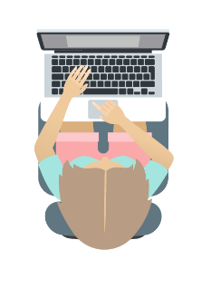Testing Tips:  
Take the required sample exam to get a feel for how the software works.  
Make sure you have a working microphone and camera on your laptop ***before*** taking the exam.  
Know the test parameters (ie. is scrap paper allowed, bathroom breaks etc)  
As with any test, don’t wait until the last minute to take the exam.